Whois Component Diagram

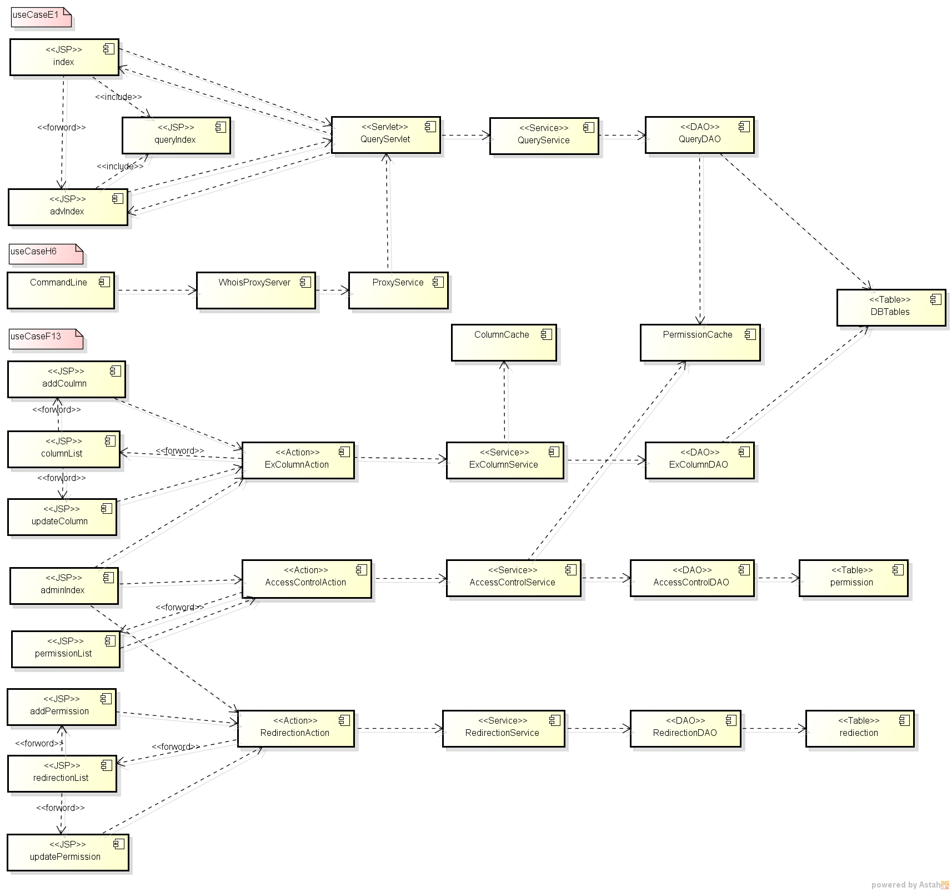

1. UseCase 1 describes the query program flow chart of the operation of the entire query, when user input data and query the index page, to be followed trigger queryServlet operation to carry out the corresponding parameters to trigger after queryService business processing and call queryDAO toquery the database, then so return and data display page until queryIndex page.
2. UseCase 6 used in the query cache.
3. UseCase 13 describes the management of the administrator field, permissions, and redirection